**Hypercube Dimensions and Communication Steps:**

“k” represents the dimensional structure of the cube. “n” represents the number of processors.

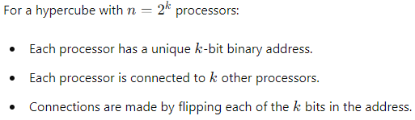

Taking log2 on both the sides: log2 (n) = k log2 (2); k = log2 (n).

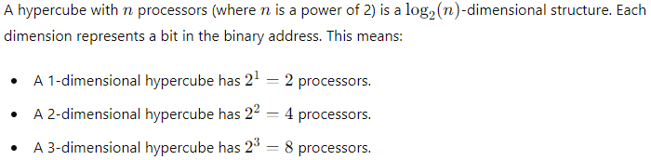



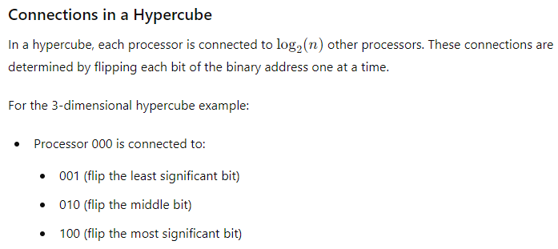

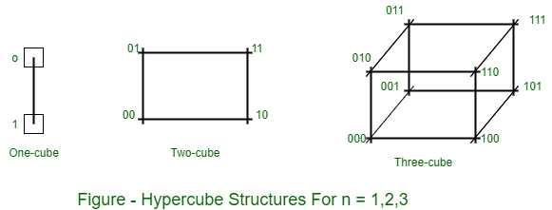

**Parallel Computation Example:**

Let's revisit the parallel summation example with 𝑛 = 8 (a 3-dimensional hypercube):

Initial State:

Each processor starts with one value.

Step 1:

Each processor exchanges its value with the processor whose address differs by one bit in the least significant position.

Step 2:

Each processor exchanges the new value with the processor whose address differs by one bit in the next significant position.

Step 3:

Each processor exchanges the aggregated result with the processor whose address differs by one bit in the most significant position.

**Step 1:**

000 <-> 001

010 <-> 011

100 <-> 101

110 <-> 111

**Step 2:**

000 <-> 010

001 <-> 011

100 <-> 110

101 <-> 111

**Step 3:**

000 <-> 100

001 <-> 101

010 <-> 110

011 <-> 111